Project Title
Project scheduling with precedence constraints
Project Report submitted for the partial fulfilment of grade for the course

Data Structures and Algorithms -3 (25CS2103E)
in

A.Y. 2026-2027

Submitted by
Aakash Dadhirao (2520030337)
Souradeepta Das (2520030347)
V. Sai Nikhil (2520030255)

Team Number: 14
Section: 7

Under the guidance of

Dr. S. Madhavi

Professor, Department of Computer Science Engineering
Hyderabad-500090, Telangana, India.

K L (Deemed to be) University
DEPARTMENT OF COMPUTER SCIENCE ENGINEERING



DECLARATION

The Mini Project Report entitled “Project scheduling with precedence constraints” is a record of Bonafide work of Aakash Dadhirao – 2520030337, Souradeepta Das – 2520030347, V. Sai Nikhil – 2520030255 submitted in partial fulfillment for the award of B. Tech in Computer Science and Engineering to the K L University. The results embodied in this report have not been copied from any other departments/University/Institute.

Aakash Dadhirao – 2520030337
Souradeepta Das – 2520030347
V. Sai Nikhil – 2520030255

K L (Deemed to be) University
DEPARTMENT OF COMPUTER SCIENCE ENGINEERING
CERTIFICATE

This is to certify that the mini project based report entitled “Project scheduling with precedence constraints” is a bonafide work done and submitted by Aakash Dadhirao – 2520030337, Souradeepta Das – 2520030347, V. Sai Nikhil – 2520030255 in partial fulfillment of the requirements for the award of the degree of BACHELOR OF TECHNOLOGY in Department of Computer Science Engineering, K L (Deemed to be University), during the academic year 2026-2027.

Signature of the Supervisor

Signature of the HOD Signature of the External Examiner

ACKNOWLEDGEMENT

The success of this project would not have been possible without the timely help and guidance rendered by many people. We wish to express our sincere thanks to all those who have assisted us in one way or the other in the completion of our project.

Our greatest appreciation goes to our guide, Dr. S. Madhavi, Professor, Department of Computer Science Engineering, whose tremendous support, encouragement and guidance cannot be expressed in words.

We express our gratitude to Dr. P. Venkateshwar Rao (CSE), Head of the Department of Computer Science Engineering, for providing us with adequate facilities, ways and means by which we were able to complete this project-based lab.

We thank all the members of the teaching and non-teaching staff, and all those who have assisted us directly or indirectly in the successful completion of this project. Finally, we sincerely thank our parents, friends and classmates for their kind help and cooperation during our work.

Aakash Dadhirao – 2520030337
Souradeepta Das – 2520030347
V. Sai Nikhil – 2520030255

TABLE OF CONTENTS

S.No. | Contents | Page no.
1. | Abstract | 6
2. | Introduction | 7
3. | Literature survey | 8
4. | Problem Statement and Objectives | 10
5. | Hardware and Software requirements | 11
6. | Implementation | 12
7. | Results & Discussion | 18
8. | Conclusion & Future Scope | 23
9. | References | 24

1. ABSTRACT
This project presents a dual-interface Directed Acyclic Graph (DAG) engine for modelling, scheduling and allocating resources to workflows governed by precedence constraints. Task data is ingested through a custom, fault-tolerant CSV parser and represented as a DAG. Four algorithms, each mapped to a Course Outcome of Data Structures and Algorithms-3, form the analytical core. Kahn’s algorithm (CO1) derives a valid execution order and detects cyclic dependencies in O(V + E) time, raising a “DEADLOCK DETECTED” exception when no order exists. The Knuth–Morris–Pratt algorithm (CO2) drives a real-time search bar that filters tasks by name or identifier in O(N + M) time. The Critical Path Method (CO3) applies a two-pass dynamic programme to compute earliest and latest times and slack, isolating the zero-slack critical path in O(V + E). The Edmonds–Karp maximum-flow algorithm (CO4) distributes pending tasks across workers with individual capacity limits on a capacitated bipartite network in O(V·E²). The system is written in Java with Swing and custom Java 2D rendering, and offers two views of one engine: Overwatch, a dark-themed enterprise analytics terminal, and Overdrive, a gamified dashboard that recasts tasks as quests with rarities and XP. Verification on a representative eight-task project confirmed correct ordering, a 21-unit project duration, accurate slack values, reliable cycle detection and capacity-respecting allocation.
Team Name: 14
Team Logo (if any): Not applicable
Team Members:
- Aakash Dadhirao, 2520030337
- Souradeepta Das, 2520030347
- V. Sai Nikhil, 2520030255
- INTRODUCTION
Modern software, construction, manufacturing and research projects are rarely a flat list of jobs. They consist of tens to thousands of tasks bound by precedence constraints: a task cannot begin until each of its prerequisites has finished. Such structures are naturally modelled as a Directed Acyclic Graph (DAG), in which vertices represent tasks and directed edges represent “must finish before” relationships. Managing this graph manually is error-prone. A single circular dependency makes a plan impossible to execute, the tasks that truly control the finish date remain hidden, locating a task in a large plan is slow, and work is unevenly spread across the available people.
What. This project, Project Scheduling with Precedence Constraints, is a Java-based DAG engine that models a workflow, validates its dependencies, schedules it, and allocates its tasks to a workforce. Task data is read through a fault-tolerant custom CSV parser, and the results are presented through two graphical front-ends built with Java Swing and custom Java 2D rendering [11], [12]. Overwatch is a dark-themed enterprise analytics terminal with left-accented metric cards, real-time epoch timers and critical-path warning flags. Overdrive is a gamified, RPG-themed campaign dashboard in which tasks become “quests” with rarities from Common to Legendary, XP rewards, neon progress bars and custom-painted pill badges.
Why. The project demonstrates that four advanced Data Structures and Algorithms concepts are not isolated textbook exercises but cooperate inside a single realistic system. Each concept corresponds to a Course Outcome of Data Structures and Algorithms-3: Kahn’s algorithm for precedence evaluation and deadlock detection (CO1), the Knuth–Morris–Pratt algorithm for linear-time string matching (CO2), dynamic programming on DAGs through the Critical Path Method (CO3), and Edmonds–Karp maximum flow for capacity-constrained allocation (CO4).
How. The system follows a layered design. A data layer loads and validates tasks into an adjacency-list graph; an algorithm layer runs the four modules over that graph; and a presentation layer renders the outcomes in both dashboards. The same engine therefore serves a professional analytics audience and a gamified audience without any duplication of logic.
The remainder of this report is organised as follows. Section 3 reviews related work. Section 4 states the problem and objectives. Section 5 lists the hardware and software requirements. Section 6 describes the implementation of the algorithmic modules. Section 7 presents the results and discussion. Section 8 concludes the report and outlines future scope, and Section 9 lists the references.
- LITERATURE SURVEY
The following existing systems and foundational works were studied. The first four are practical systems or tools that deal with dependency graphs and project scheduling; the remainder are the primary sources for the algorithms used in this project.
1. Apache Airflow [1]. Airflow is an open-source platform for authoring, scheduling and monitoring workflows that are declared as DAGs of tasks with explicit dependencies. Its documentation treats the DAG as the central abstraction and includes DAG visualisation and run control. Airflow is concerned with automated execution of data pipelines; it is not aimed at critical-path slack analysis, string-matching task search or capacity-limited assignment of tasks to people, which this project brings together in one engine.
2. Gradle task graph [2]. Gradle builds a directed acyclic graph of tasks across all projects before executing any task, and uses the declared dependencies to decide which tasks run and in what order. It is a production example of topological ordering, and its model depends on the graph being acyclic, which is exactly the invariant that Kahn’s algorithm verifies in our engine. Gradle, however, targets software builds rather than project planning.
3. GanttProject [3]. GanttProject is an open-source task and project management tool that displays Gantt charts and PERT views, records tasks, resources and dependencies, and can show the critical path of a plan. It establishes the Critical Path Method as the standard analysis for project schedules. The present project reproduces this analysis through an explicit forward and backward pass, and extends it with KMP-based search, flow-based workforce allocation and a second, gamified interface.
4. GAO Schedule Assessment Guide [4]. This guidance document describes how early start and finish dates are computed by a forward pass, how late dates are computed by a backward pass, and how the difference between them defines total float. It confirms the two-pass formulation and the zero-float definition of the critical path that our CO3 module implements.
5. Kahn, “Topological sorting of large networks” [5]. Kahn’s 1962 paper introduced the queue-based method of repeatedly removing vertices with no incoming edges to obtain a linear ordering of a network. A residual set of vertices that can never be removed signals a cycle. This is the basis of our CO1 module and of its “DEADLOCK DETECTED” check.
6. Knuth, Morris and Pratt, “Fast pattern matching in strings” [6]. The 1977 paper presents a string-matching algorithm that preprocesses the pattern into a failure table so that the text pointer never moves backwards, giving a running time linear in the combined length of text and pattern. Our CO2 module uses this idea for the live search bar.
7. Kelley and Walker, “Critical-path planning and scheduling” [7]. This 1959 work introduced the Critical Path Method for scheduling projects whose activities are linked by precedence relations. It defines the earliest and latest event times and the slack of each activity, which are the quantities computed by our CO3 module.
8. Edmonds and Karp, “Theoretical improvements in algorithmic efficiency for network flow problems” [8]. The paper shows that always augmenting along a shortest path (found by breadth-first search) bounds the number of augmentations independently of the capacities, giving a polynomial running time. Our CO4 module follows this strategy on a bipartite task–worker network.
9. Cormen, Leiserson, Rivest and Stein, “Introduction to Algorithms” [9]. The standard textbook covers topological sorting, string matching, dynamic programming on DAGs and the Edmonds–Karp analysis with complete proofs of the complexity bounds quoted in this report.
10. cp-algorithms: Maximum flow [10]. This practical reference describes the implementation of Edmonds–Karp with a residual graph and a BFS that records parent edges, and states the O(V·E²) bound that holds even for irrational capacities. It guided the residual-edge structure used in our allocator.
Research gap. To the best of our knowledge, the tools above address either graph execution or schedule visualisation, whereas this project combines deadlock detection, linear-time search, critical-path dynamic programming and maximum-flow workforce allocation behind two distinct, custom-rendered interfaces.
- Problem Statement and Objectives
Problem Statement: To design and implement a DAG-based scheduling engine that validates precedence constraints, identifies the critical path, supports fast task retrieval and allocates tasks to capacity-limited workers in large-scale project workflows.
Problem Description: In large projects with hundreds of interdependent tasks, circular dependencies, hidden critical tasks, slow manual look-up and uneven workload distribution cause schedule overruns and are impractical to detect by inspection; an automated and algorithmically sound tool is therefore required.
Objectives:
Identify the Project’s Purpose: The project was initiated to show, through one coherent application, how four core Data Structures and Algorithms concepts solve a practical business problem: planning and executing precedence-constrained work on time and within workforce limits. Guided by this purpose, the objectives are:
- To model a project as a Directed Acyclic Graph using an adjacency list and an in-degree map, and to ingest task data through a robust custom CSV parser.
- To compute a valid execution order and detect cyclic dependencies (deadlocks) using Kahn’s algorithm in O(V + E) time (CO1).
- To implement the Knuth–Morris–Pratt algorithm for real-time, linear-time O(N + M) filtering of tasks by name or ID (CO2).
- To apply two-pass dynamic programming (Critical Path Method) to compute earliest and latest times, slack and the critical path in O(V + E) time (CO3).
- To allocate pending tasks to workers with individual capacities using Edmonds–Karp maximum flow on a capacitated bipartite network, separating assigned tasks from unassigned overflow (CO4).
- To present the results through two custom-rendered Java Swing interfaces, Overwatch (enterprise analytics) and Overdrive (gamified), so that the analysis is intuitive for different audiences.
- HARDWARE AND SOFTWARE REQUIREMENTS
Hardware Requirements:
- Processor: Intel Core i3 / AMD Ryzen 3 or higher (dual-core, 2.0 GHz or above)
- Memory (RAM): 4 GB minimum; 8 GB recommended for large task graphs
- Storage: At least 500 MB of free disk space
- Display: 1366 × 768 minimum; 1920 × 1080 recommended for the custom-rendered dashboards
- Peripherals: Standard keyboard and mouse
Software Requirements:
- Operating System: Windows 10/11, Ubuntu 20.04 or later, or macOS (any platform with a Java runtime)
- Language and Runtime: Java Development Kit (JDK) 17 or later
- GUI and Graphics: Java Swing with Java 2D Graphics (custom painting using Graphics2D) [11], [12]
- Data Handling: Custom CSV parsing engine (no external libraries required)
- Development Tools: IntelliJ IDEA, Eclipse or Visual Studio Code
- IMPLEMENTATION
6.1 System Architecture
The application is organised in three layers. The data layer reads a CSV file of tasks into a map of Task objects; the algorithm layer applies the four modules in sequence; and the presentation layer renders the results in either dashboard. Table 6.1 summarises the layers.
Table 6.1: Layered architecture of the system
Layer | Components | Responsibility
Presentation | Overwatch and Overdrive front-ends (Java Swing, Java 2D custom rendering) | Draw metric cards, quest cards, badges and progress bars; capture search text and workforce input
Algorithm | TopologicalSorter, KMPSearch, CriticalPathMethod, WorkforceAllocator | Order and validate tasks (CO1), search (CO2), schedule (CO3), allocate (CO4)
Data | Custom CSV parser; Task model (ID, name, duration, predecessors) | Load, validate and represent the project as a DAG

The runtime flow is: CSV file → task map → Kahn’s algorithm (validation and order) → Critical Path Method (times, slack, critical flags) → dashboards. The search bar invokes the KMP filter on every keystroke, and the Dynamic Workforce Allocation tool invokes Edmonds–Karp on the pending tasks.
6.2 Course Outcome Mapping
Table 6.2: Algorithms, data structures and complexity per Course Outcome
Course Outcome | Algorithm | Core data structures | Time complexity | Role in the system
CO1: Advanced strategy / problem evaluation | Kahn’s algorithm (BFS topological sort) | Adjacency list, in-degree map, queue | O(V + E) | Execution order; deadlock detection
CO2: Linear-time string matching | Knuth–Morris–Pratt | LPS (failure) array | O(N + M) | Real-time task search
CO3: Dynamic programming on DAGs | Critical Path Method (two-pass DP) | Topological order; ES, EF, LS, LF values | O(V + E) | Slack and critical path
CO4: Network flow and capacity constraints | Edmonds–Karp maximum flow | Residual graph, BFS queue, parent-edge array | O(V·E²) | Workforce allocation

The listings below present the data model and the four algorithmic modules. The Swing front-end code is omitted for brevity.
6.3 Data Model
Every vertex of the DAG is a Task carrying its identifier, name, duration and list of predecessor IDs, together with the fields filled by the Critical Path Method.
Listing 6.1: Task.java
import java.util.*;

/** Domain model: one node of the project DAG. */
public class Task {
public final String id, name;
public final int duration;
public final List<String> deps = new ArrayList<>(); // predecessor IDs
public int es, ef, ls, lf, slack; // filled by CPM
public boolean critical;

public Task(String id, String name, int duration, String... deps) {
this.id = id; this.name = name; this.duration = duration;
this.deps.addAll(Arrays.asList(deps));
}
}

6.4 Module 1: Kahn’s Algorithm (CO1)
The module builds an adjacency list (predecessor → successors) and an in-degree map. All tasks with in-degree zero are placed in a queue. Repeatedly, a task is dequeued and appended to the order, and the in-degree of each successor is decremented; a successor whose in-degree reaches zero is enqueued. If the final order contains fewer tasks than the graph, the remaining tasks lie on or behind a cycle and a “DEADLOCK DETECTED” exception is thrown. Each vertex is enqueued once and each edge is examined once, giving O(V + E) time.
Listing 6.2: TopologicalSorter.java
import java.util.*;

/** CO1 - Kahn's algorithm (BFS topological sort) with cycle detection. O(V + E). */
public class TopologicalSorter {

public static List<Task> sort(Map<String, Task> tasks) {
Map<String, List<String>> adj = new HashMap<>(); // adjacency list: pred -> succs
Map<String, Integer> inDeg = new HashMap<>(); // in-degree mapping
for (Task t : tasks.values()) {
adj.putIfAbsent(t.id, new ArrayList<>());
inDeg.putIfAbsent(t.id, 0);
}
for (Task t : tasks.values())
for (String p : t.deps) {
if (!tasks.containsKey(p))
throw new IllegalArgumentException(
"Unknown predecessor '" + p + "' for " + t.id);
adj.get(p).add(t.id);
inDeg.merge(t.id, 1, Integer::sum);
}

Deque<String> queue = new ArrayDeque<>();
for (var e : inDeg.entrySet()) if (e.getValue() == 0) queue.add(e.getKey());

List<Task> order = new ArrayList<>();
while (!queue.isEmpty()) {
String u = queue.poll();
order.add(tasks.get(u));
for (String v : adj.get(u))
if (inDeg.merge(v, -1, Integer::sum) == 0) queue.add(v);
}
if (order.size() != tasks.size()) // some nodes never reached in-degree 0
throw new IllegalStateException("DEADLOCK DETECTED: cyclic dependency among "
+ (tasks.size() - order.size()) + " task(s)");
return order;
}
}

6.5 Module 2: Knuth–Morris–Pratt Search (CO2)
The module first computes the LPS array, where LPS[i] is the length of the longest proper prefix of the pattern that is also a suffix of its first i + 1 characters. During matching, a mismatch moves the pattern pointer back through the LPS table while the text pointer never retreats, so the search takes O(N + M) time for a text of length N and a pattern of length M. The filter method applies the match, case-insensitively, to both the task name and the task ID and powers the search bar of both dashboards.
Listing 6.3: KMPSearch.java
import java.util.*;

/** CO2 - Knuth-Morris-Pratt string matching. O(N + M). */
public class KMPSearch {

/** Longest Proper Prefix which is also Suffix table for the pattern. */
static int[] buildLPS(String p) {
int[] lps = new int[p.length()];
for (int i = 1, len = 0; i < p.length(); ) {
if (p.charAt(i) == p.charAt(len)) lps[i++] = ++len;
else if (len > 0) len = lps[len - 1]; // fall back, never re-scan text
else lps[i++] = 0;
}
return lps;
}

/** Returns true if pattern occurs in text (case-insensitive). */
public static boolean contains(String text, String pattern) {
if (pattern.isEmpty()) return true;
String t = text.toLowerCase(), p = pattern.toLowerCase();
int[] lps = buildLPS(p);
for (int i = 0, j = 0; i < t.length(); ) {
if (t.charAt(i) == p.charAt(j)) { i++; j++; }
if (j == p.length()) return true;
else if (i < t.length() && t.charAt(i) != p.charAt(j)) {
if (j > 0) j = lps[j - 1]; else i++;
}
}
return false;
}

/** Live-search filter used by both dashboards: match on task name OR ID. */
public static List<Task> filter(Collection<Task> tasks, String query) {
List<Task> out = new ArrayList<>();
for (Task t : tasks)
if (contains(t.name, query) || contains(t.id, query)) out.add(t);
return out;
}
}

6.6 Module 3: Critical Path Method (CO3)
The module is a two-pass dynamic programme over the topological order. In the forward pass, ES(v) = max EF(u) over all predecessors u, and EF(v) = ES(v) + duration(v); the largest EF is the project duration. In the backward pass, LF(u) = min LS(v) over all successors v, and LS(u) = LF(u) − duration(u). The slack of a task is LS − ES, and tasks with zero slack form the critical path. Because each task and each dependency is processed a constant number of times, the running time is O(V + E).
Listing 6.4: CriticalPathMethod.java
import java.util.*;

/** CO3 - Critical Path Method as a two-pass DP over the topological order. O(V + E). */
public class CriticalPathMethod {

/** @return project duration (makespan); fills ES/EF/LS/LF/slack/critical per Task. */
public static int compute(Map<String, Task> tasks, List<Task> topo) {
int makespan = 0;
// Forward pass: ES = max(EF of predecessors), EF = ES + duration
for (Task t : topo) {
t.es = 0;
for (String p : t.deps) t.es = Math.max(t.es, tasks.get(p).ef);
t.ef = t.es + t.duration;
makespan = Math.max(makespan, t.ef);
}
// Backward pass: LF = min(LS of successors), LS = LF - duration
for (Task t : topo) t.lf = makespan;
for (int i = topo.size() - 1; i >= 0; i--) {
Task t = topo.get(i);
t.ls = t.lf - t.duration;
for (String p : t.deps) {
Task pr = tasks.get(p);
pr.lf = Math.min(pr.lf, t.ls);
}
}
// Slack / float; zero slack => critical path
for (Task t : topo) {
t.slack = t.ls - t.es;
t.critical = (t.slack == 0);
}
return makespan;
}
}

6.7 Module 4: Edmonds–Karp Workforce Allocation (CO4)
The allocator builds a capacitated network with a source S, one vertex per pending task, one vertex per worker, and a sink T. Edges S → task have capacity 1, edges task → worker have capacity 1, and edges worker → T carry the worker’s declared maximum number of tasks. Edmonds–Karp repeatedly finds a shortest augmenting path by BFS and pushes the bottleneck flow along it. The maximum flow equals the largest number of tasks that can be assigned without exceeding any capacity. A task whose edge to some worker is saturated is assigned to that worker; a task with no saturated edge is reported as unassigned overflow. The running time is O(V·E²).
Listing 6.5: WorkforceAllocator.java
import java.util.*;

/** CO4 - Edmonds-Karp max-flow on a capacitated bipartite network. O(V * E^2). */
public class WorkforceAllocator {
private final int n;
private final List<int[]> edges = new ArrayList<>(); // {to, cap}; edge i^1 = reverse
private final List<List<Integer>> g = new ArrayList<>();

private WorkforceAllocator(int n) {
this.n = n;
for (int i = 0; i < n; i++) g.add(new ArrayList<>());
}

private void addEdge(int u, int v, int cap) {
g.get(u).add(edges.size()); edges.add(new int[]{v, cap});
g.get(v).add(edges.size()); edges.add(new int[]{u, 0});
}

private int maxFlow(int s, int t) {
int flow = 0;
while (true) {
int[] parentEdge = new int[n]; Arrays.fill(parentEdge, -1);
Deque<Integer> q = new ArrayDeque<>(List.of(s));
boolean[] seen = new boolean[n]; seen[s] = true;
while (!q.isEmpty() && !seen[t]) { // BFS => shortest augmenting path
int u = q.poll();
for (int id : g.get(u)) {
int[] e = edges.get(id);
if (!seen[e[0]] && e[1] > 0) {
seen[e[0]] = true; parentEdge[e[0]] = id; q.add(e[0]);
}
}
}
if (!seen[t]) return flow; // no augmenting path left
int push = Integer.MAX_VALUE;
for (int v = t; v != s; v = edges.get(parentEdge[v] ^ 1)[0])
push = Math.min(push, edges.get(parentEdge[v])[1]);
for (int v = t; v != s; v = edges.get(parentEdge[v] ^ 1)[0]) {
edges.get(parentEdge[v])[1] -= push;
edges.get(parentEdge[v] ^ 1)[1] += push;
}
flow += push;
}
}

/** Assign tasks to workers; workerCap = max number of tasks each worker can take. */
public static Map<String, List<String>> allocate(List<Task> pending,
Map<String, Integer> workerCap, List<Task> unassignedOut) {
List<String> workers = new ArrayList<>(workerCap.keySet());
int T = pending.size(), W = workers.size(), S = 0, K = T + W + 1;
WorkforceAllocator net = new WorkforceAllocator(T + W + 2);
for (int i = 0; i < T; i++) {
net.addEdge(S, 1 + i, 1); // source -> task (cap 1)
for (int w = 0; w < W; w++)
net.addEdge(1 + i, 1 + T + w, 1); // task -> worker (cap 1)
}
for (int w = 0; w < W; w++) // worker -> sink (capacity)
net.addEdge(1 + T + w, K, workerCap.get(workers.get(w)));
net.maxFlow(S, K);

Map<String, List<String>> result = new LinkedHashMap<>();
for (String w : workers) result.put(w, new ArrayList<>());
for (int i = 0; i < T; i++) {
boolean placed = false;
for (int id : net.g.get(1 + i)) {
int[] e = net.edges.get(id);
boolean forward = (id % 2 == 0) && e[0] > T && e[0] <= T + W;
if (forward && e[1] == 0) { // saturated edge => flow used
result.get(workers.get(e[0] - T - 1)).add(pending.get(i).id);
placed = true; break;
}
}
if (!placed) unassignedOut.add(pending.get(i));
}
return result;
}
}

- RESULTS & DISCUSSION
7.1 Test Project
The algorithmic modules were executed on a representative eight-task software-delivery project defined in Table 7.1. Durations are in abstract time units.
Table 7.1: Sample project used for verification
ID | Task | Duration | Predecessors
T1 | Requirements Analysis | 3 | —
T2 | System Design | 4 | T1
T3 | Database Schema | 3 | T2
T4 | UI Prototype | 3 | T2
T5 | Backend Development | 6 | T3
T6 | Frontend Development | 3 | T4
T7 | Integration Testing | 3 | T5, T6
T8 | Deployment | 2 | T7

7.2 Algorithm Outputs
Topological order (CO1). Kahn’s algorithm returned the order T1, T2, T3, T4, T5, T6, T7, T8, in which every task appears after all of its predecessors.
Critical Path Method (CO3). The project duration is 21 units. Table 7.2 gives the computed times.
Table 7.2: Critical Path Method output
Task | ES | EF | LS | LF | Slack | Critical
T1 | 0 | 3 | 0 | 3 | 0 | Yes
T2 | 3 | 7 | 3 | 7 | 0 | Yes
T3 | 7 | 10 | 7 | 10 | 0 | Yes
T4 | 7 | 10 | 10 | 13 | 3 | No
T5 | 10 | 16 | 10 | 16 | 0 | Yes
T6 | 10 | 13 | 13 | 16 | 3 | No
T7 | 16 | 19 | 16 | 19 | 0 | Yes
T8 | 19 | 21 | 19 | 21 | 0 | Yes

The critical path is T1 → T2 → T3 → T5 → T7 → T8. The UI branch (T4, T6) has three units of slack, so it can slip by up to three units without delaying delivery.
KMP search (CO2). Table 7.3 lists the queries executed against the task names and IDs.
Table 7.3: KMP search results
Query | Searched in | Result
dev | Task name / ID | T5 Backend Development; T6 Frontend Development
t6 | Task name / ID | T6 Frontend Development
zzz | Task name / ID | No match (0 tasks)
ababc | Text “abababcabab” | Found (prefix-fallback case)
aaab | Text “aaaa” | Not found (repetitive-pattern case)

Deadlock detection (CO1). A three-task cycle (A depends on C, B on A, C on B) was supplied. The sorter halted and raised: DEADLOCK DETECTED: cyclic dependency among 3 task(s).
Workforce allocation (CO4). The eight tasks were allocated to three workers: Asha (capacity 3), Ravi (capacity 2) and Meera (capacity 2). The total capacity of 7 is one short of the 8 tasks, so the maximum flow is 7 (Table 7.4). When Meera’s capacity was raised to 3, all 8 tasks were assigned and no overflow remained.
Table 7.4: Edmonds–Karp allocation result
Worker | Capacity | Assigned tasks | Load
Asha | 3 | T1, T2, T3 | 3 / 3
Ravi | 2 | T4, T5 | 2 / 2
Meera | 2 | T6, T7 | 2 / 2
Unassigned overflow | — | T8 | —

7.3 Application Screenshots

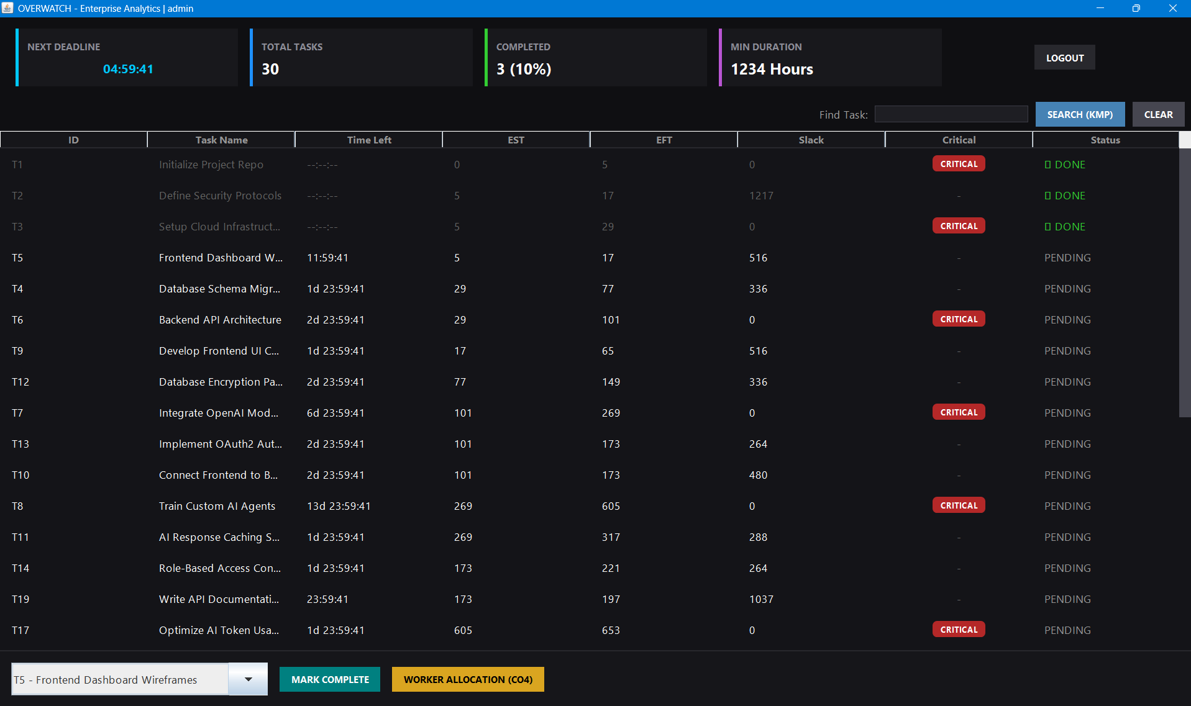
Fig. 7.1: Overwatch enterprise dashboard
Overwatch presents left-accented metric cards, real-time epoch timers and critical-path warning flags for zero-slack tasks.
Its dark, custom-rendered layout gives a project manager an at-a-glance view of schedule health.

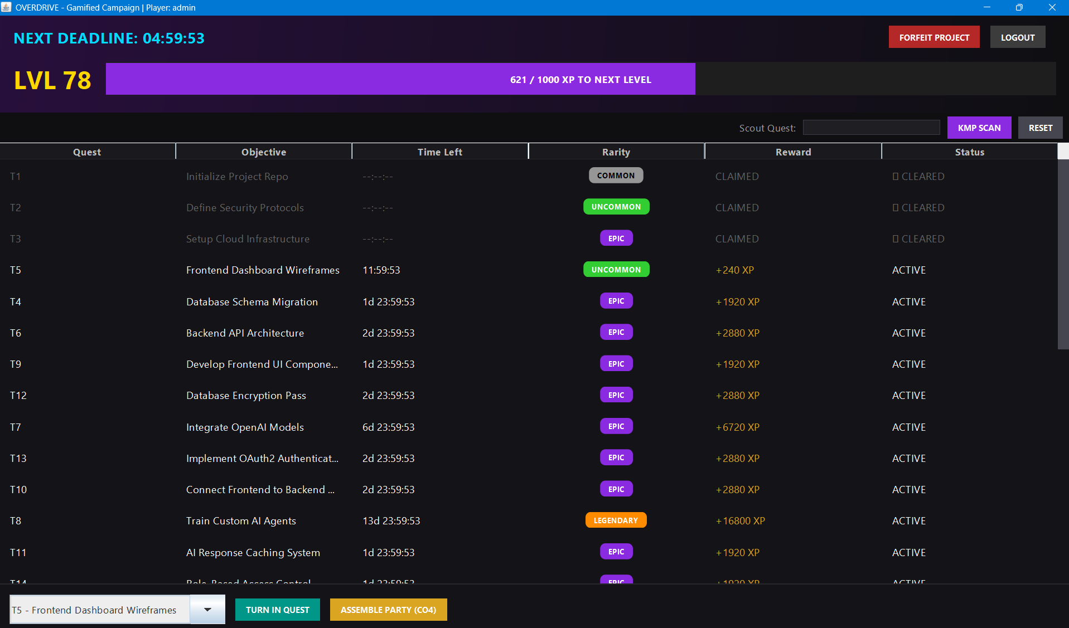
Fig. 7.2: Overdrive gamified dashboard
Overdrive shows tasks as quests with Common-to-Legendary rarities, XP rewards, neon progress bars and pill badges.
Critical-path tasks receive boosted rarity and XP, turning schedule risk into visible priority.

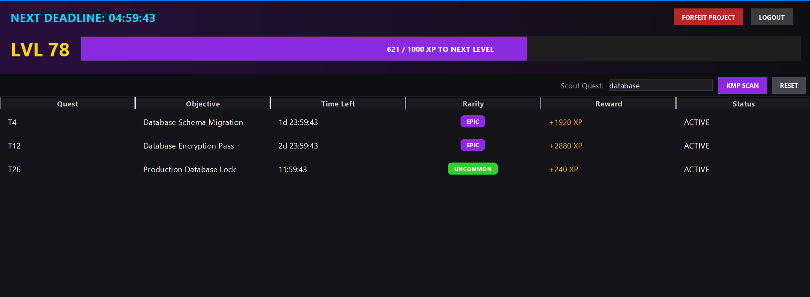
Fig. 7.3: Real-time KMP search
Typing in the search bar filters the task list instantly using KMP in O(N + M) time on both dashboards.
Matching is performed on the task name or the task ID.

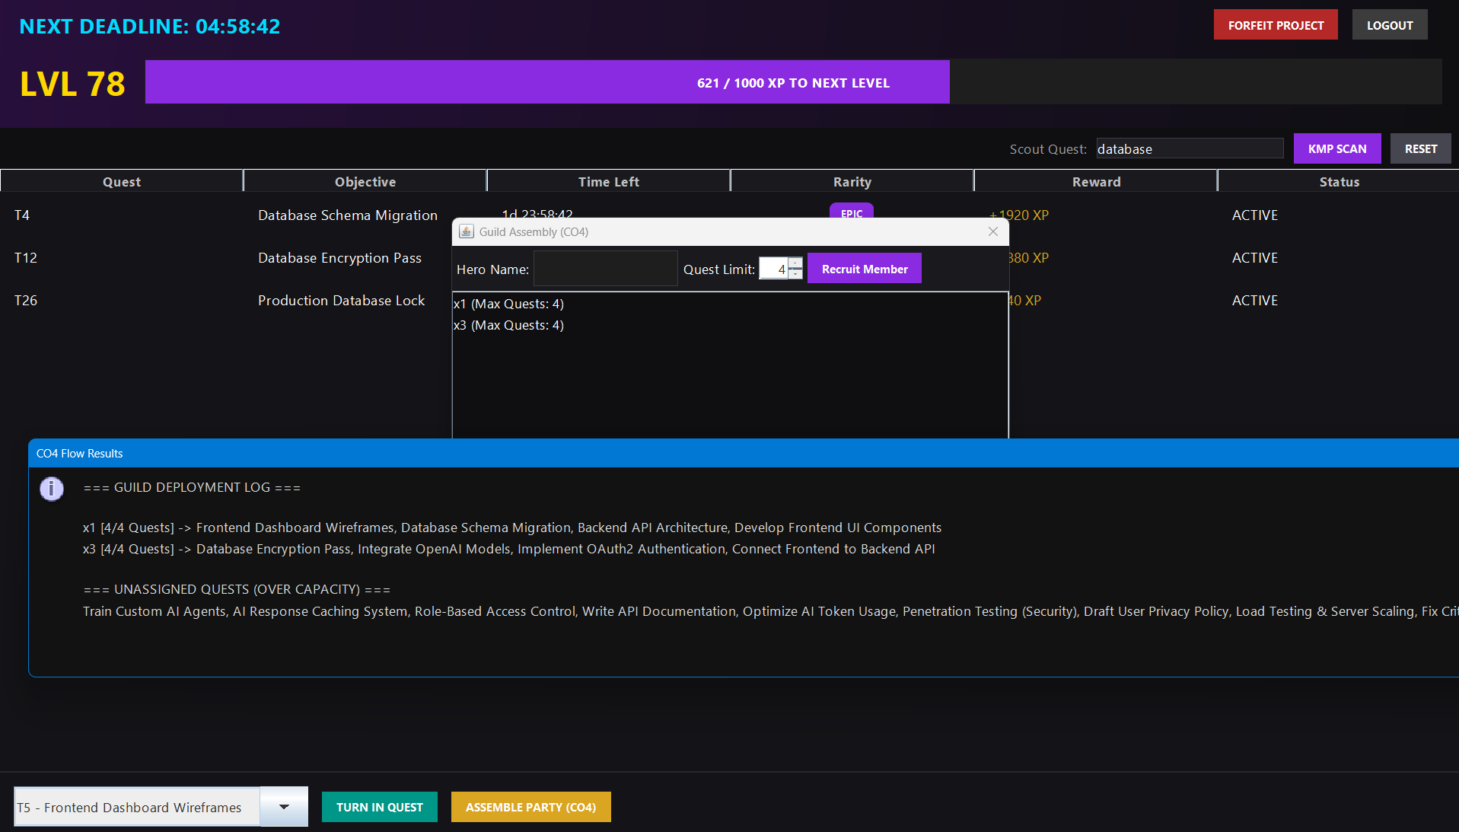
Fig. 7.4: Dynamic Workforce Allocation
Users enter workers and their maximum task capacities, and Edmonds–Karp distributes the pending tasks without exceeding any limit.
The result separates assigned tasks from unassigned overflow.

7.4 Discussion
CO1. Kahn’s algorithm produced a correct order for the acyclic project and rejected the cyclic input. Because it processes each vertex and edge once, validation remains O(V + E) and can run on every file load before any schedule is shown.
CO2. The KMP filter returned exactly the tasks whose name or ID contained the query, including the repetitive-pattern case where a naive matcher would re-scan the text. The text pointer never moves backwards, which keeps the search bar responsive as the plan grows.
CO3. The forward and backward passes yielded a 21-unit duration and a six-task critical path, while the parallel UI branch showed three units of slack. These slack values drive the critical-path warning flags in Overwatch and the rarity and XP scaling in Overdrive, so a single computation serves both interfaces.
CO4. The allocation respected every worker’s capacity. The number of assigned tasks equals min(number of tasks, total capacity), which is the value of the maximum flow; this is why exactly one task overflowed in the first scenario and none in the second. Which particular task is left unassigned depends on the order in which augmenting paths are found, but the total number assigned does not.
- CONCLUSION & FUTURE SCOPE
Conclusion. The project set out to build a DAG engine that validates precedence constraints, finds the critical path, supports fast search and allocates tasks within workforce capacities, and to present it through two distinct interfaces. All of these objectives were met. Kahn’s algorithm (CO1) provides ordering and deadlock detection, the Knuth–Morris–Pratt algorithm (CO2) provides linear-time search, the Critical Path Method (CO3) provides slack and critical-path analysis through dynamic programming, and the Edmonds–Karp algorithm (CO4) provides capacity-respecting workforce allocation. Verification on a representative project confirmed the expected outputs. The key takeaway is that classical algorithms with proven complexity bounds combine naturally into a practical planning tool, and that one engine can power both an enterprise and a gamified experience.
Future Scope. Possible enhancements are grouped by horizon.
Near term
- Add PERT three-point duration estimates and export of schedules and allocations to CSV and PDF.
- Allow in-application editing of tasks and dependencies with undo and redo.
- Show richer error messages that name the exact tasks forming a detected cycle.
Medium term
- Replace Edmonds–Karp with Dinic’s algorithm for larger networks, and add skill-based eligibility and costs through min-cost maximum flow.
- Recompute the Critical Path Method incrementally when a single task changes.
- Add a Gantt chart view and persistent storage of projects.
Long term
- Provide a web-based, collaborative version with real-time multi-user editing.
- Predict task durations from historical data and integrate with issue trackers.
- Extend to resource-constrained scheduling of multiple concurrent projects.
- REFERENCES

[1] Apache Software Foundation, “Core Concepts: DAGs,” Apache Airflow Documentation. [Online]. Available: https://airflow.apache.org/docs/apache-airflow/2.11.2/core-concepts/index.html
[2] Gradle Inc., “Build Lifecycle,” Gradle User Manual. [Online]. Available: https://docs.gradle.org/current/userguide/build_lifecycle.html
[3] “Project Management with GanttProject,” Open Source For You, Mar. 2013. [Online]. Available: https://www.opensourceforu.com/2013/03/project-management-with-ganttproject/
[4] U.S. Government Accountability Office, “Early and Late Dates,” in Schedule Assessment Guide. [Online]. Available: https://gaoinnovations.gov/schedule-guide/early-and-late-dates.html
[5] A. B. Kahn, “Topological sorting of large networks,” Commun. ACM, vol. 5, no. 11, pp. 558–562, 1962.
[6] D. E. Knuth, J. H. Morris Jr., and V. R. Pratt, “Fast pattern matching in strings,” SIAM J. Comput., vol. 6, no. 2, pp. 323–350, 1977.
[7] J. E. Kelley Jr. and M. R. Walker, “Critical-path planning and scheduling,” in Proc. Eastern Joint Computer Conf., Boston, MA, USA, Dec. 1959, pp. 160–173.
[8] J. Edmonds and R. M. Karp, “Theoretical improvements in algorithmic efficiency for network flow problems,” J. ACM, vol. 19, no. 2, pp. 248–264, 1972.
[9] T. H. Cormen, C. E. Leiserson, R. L. Rivest, and C. Stein, Introduction to Algorithms, 4th ed. Cambridge, MA, USA: MIT Press, 2022.
[10] “Maximum flow: Ford-Fulkerson and Edmonds-Karp,” cp-algorithms. [Online]. Available: https://cp-algorithms.com/graph/edmonds_karp.html
[11] Oracle, “Creating a GUI With Swing,” The Java Tutorials. [Online]. Available: https://docs.oracle.com/javase/tutorial/uiswing/
[12] Oracle, “2D Graphics,” The Java Tutorials. [Online]. Available: https://docs.oracle.com/javase/tutorial/2d/

